**T1** 2023

Coverity Scan Static Analysis Report

Hardhard Enterprises

Statement of Intent

Overview

This document aims to provide a record of static code analysis performed on a specific issue from the Coverity SAST scan for the NASA ION Open-Source code 4.1.1 project.

The primary purpose of this document is to validate the issue identified via the automated detection process to eliminate false positives.

Depending on findings, secondary purposes can include but are not limited to listing/providing recommended fixes alongside a list of attack vectors and potential exploits for consideration.

Reporting Best Practices

Please ensure best practices are kept when completing the document via regularly updating the Acronyms and Abbreviations table alongside any iterations made to the Document History table. This will allow other members to identify any updates and progress made across trimesters easily.

When using code snippets, please use screenshots that are clear and easy to read, alternatively, use words built-in code formatter found [here](https://appsource.microsoft.com/en-us/product/office/WA104382008?tab=Overview).

Document Naming Conventions

Naming conventions for this file are as follow; SAR_{CID}. For example, when investigating issue 123456 the file name would be SAR_123456.docx

Document History

|  |  |  |  |
| --- | --- | --- | --- |
| **Dates** | **Version** | **Author** | **Comments** |
| 27/08/2023 | V1.0 | Adharshaan Devaraj | Initial Document |
|  |  |  |  |
|  |  |  |  |

Table of Content

Contents

Introduction 3

Objective 3

Scope 3

Acronyms and Abbreviations 3

Code Review and Analysis 4

Overview 4

Observations 4

Supporting Evidence 4

Conclusions and Recommendations 4

References 5

Appendix 5

# Introduction

## Objective

The primary objective of this analysis is to determine whether the defects identified in the Coverity Report for the ION Open Source 4.1.1 project are:

* Indeed, defects.
* Potentially exploitable.

The secondary objective of this analysis, where applicable, is to provide the following:

* Recommendation(s) to fix.
* Any exploit for consideration.

## Scope

This static code analysis is limited to the ***Structurally Dead Code*** type defect identified in the following CIDs:  
***1520686***

***1520744***

***1520746***

# Acronyms and Abbreviations

Please keep an updated list of acronyms and abbreviations used throughout the report.

|  |  |
| --- | --- |
| **Acronym** | **Meaning** |
| DTN | Delay/Disruption Tolerant Network |
| ION | Interplanetary Overlay Network |
| CWE | Common Weakness Enumeration |
| BIB | Bundle Integrity Block |
| BCB | Bundle Confidentiality Block |

# Code Review and Analysis

## Overview

By analyzing “**adm_bpsec_impl.c”** code base within the **administration (adm)** folder of the Bundle Protocol v7 directory. Coverity highlighted a “**Structurally Dead Code”** error that highlights the use of dead code that cannot be executed at line 1127 in CID 1520686, 1148 in CID 1520744 and 1253 in CID 1520746. The **dtn_bpsec_get_num_good_rx_bcb_blks_src**, **dtn_bpsec_get_num_bad_rx_bcb_ blks_src and dtn_bpsec _get_num_ good_rx_bcb_bytes_src** are the three functions which contain the code that causes the error.

## Observations

The "**adm_bpsec_impl.c**" file implements functions from the BPSEC Administration API in ION, which provides the setting and administration of security policies and bundle information. In the context of BPsec, the function “**dtn_bpsec_get_num_good_rx_bcb_blks_src” in CID 1520686** is used to get the number of successfully received block control bundles (BCBs) from a certain source. In the DTN bundle protocol, block control bundles control the transmission and receipt of data blocks.

The function in **CID 1520744** is used to get the number of unsuccessfully received or "bad" block control bundles (BCBs) from a certain source. These bundles might have been received but failed security verification or had additional defects that restricted them from being handled effectively in BPsec.

The function “**dtn_bpsec_get_num_good_rx_bcb_bytes_src” in CID 1520746** implies that it might be used to obtain the total number of bytes successfully received in the form of block control bundles (BCBs) from a specified source. This might be used to monitor the quantity of data received securely via BPsec from a certain source.

The error was detected because a second return code has been written in the function. This second return code cannot be executed because another return code has been written before that hence this error is being detected. The second return code cannot be executed because the first code would have run before this hence the structurally dead code is being detected.

## Supporting Evidence

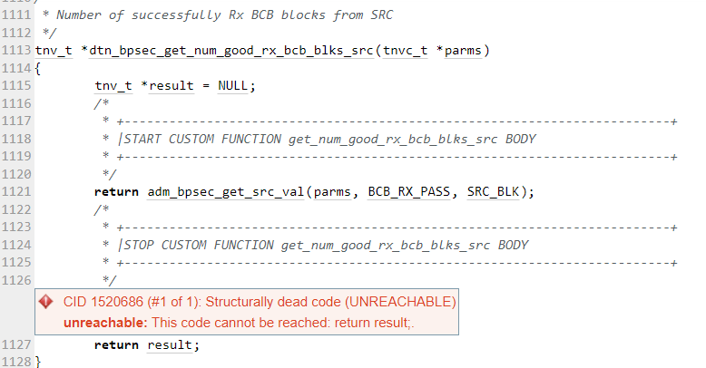

Figure - CID 1520686

The above screenshot represents the error that was identified in the code within the “**adm_bpsec_impl.c” file.** The reason for this error to be detected is the second return code that has been added to the code. (CWE, 2006)

Figure - CID 1520744

The above screenshot represents the error that was identified in the code within the “**adm_bpsec_impl.c” file.** The reason for this error to be detected is the second return code that has been added to the code. (CWE, 2006)

Figure 3 - CID 1520746

The above screenshot represents the error that was identified in the code within the “**adm_bpsec_impl.c” file.** The reason for this error to be detected is the second return code that has been added to the code. (CWE, 2006)

# Conclusions and Recommendations

This error is just a bug in the code hence to resolve this error the second return code must be removed from the function.

# References

CWE, 2006. *CWE-561: Dead Code.* [Online]   
Available at: https://cwe.mitre.org/data/definitions/561.html  
[Accessed 2023].

Appendix

Include additional information/documentation here to help the readers understand complex information.